H.T No
Regulations:
A20

Sreenidhi Institute of Science and Technology
(An Autonomous Institution)
Code No: 8A304 Date: 20-Feb-2023 (FN)

B.Tech II-Year I- Semester External Examination, February/March-2023 (Regular/Supplementary)
ELECTRICAL CIRCUITS AND NETWORKS – II (EEE)

Time: 3 Hours Max.Marks:70

Note: a) No additional answer sheets will be provided.
b) All sub-parts of a question must be answered at one place only, otherwise it will not be valued.
c) Missing data can be assumed suitably.
Bloom's Cognitive Levels of Learning (BCLL)

Remember | L1 | Apply | L3 | Evaluate | L5
Understand | L2 | Analyze | L4 | Create | L6

Part - A Max.Marks:20

Answer all QUESTIONS.

 |  | BCLL | CO(s) | Marks
1 | Explain the concept of Balanced Load. | L2 | CO1 | [2M]
2 | Calculate the time constant of RL circuit with R=10Ω and L=20mH. | L3 | CO2 | [2M]
3 | Define driving point impedance. | L1 | CO3 | [2M]
4 | What is symmetrical network? | L1 | CO4 | [2M]
5 | List the Characteristics of Filter. | L6 | CO5 | [2M]
6 | What is fourier analysis? | L1 | CO6 | [2M]
7 | What is phase sequence? | L1 | CO1 | [2M]
8 | Define zeros of a system function. | L1 | CO3 | [2M]
9 | A power level of 200 W is 3 dB above calculate other power level. | L3 | CO5 | [2M]
10 | Define singularities of a system function. | L1 | CO6 | [2M]

Part – B Max.Marks:50
ANSWER ANY FIVE QUESTIONS. EACH QUESTION CARRIES 10 MARKS.

 |  |  | BCLL | CO(s) | Marks
11. | a) | With the help of connection diagram and phasor diagram, show that two watt meters are sufficient to measure active power in a three phase three wire system with balanced star connected load. | L3 | CO1 | [5M]
 | b) | Two wattmeters connected to a 3-phase motor indicate the total power input to be 12kW. The power factor is 0.6. Determine the readings of each wattmeter. | L5 | CO1 | [5M]
12. | a) | Derive the expression for transient response of series R-C circuit driven by sinusoidal excitation by using Laplace transform method. | L5 | CO2 | [5M]
 | b) | A series RC circuit has a constant voltage of E, applied at time t = 0 as shown in Fig. below. The capacitor has no initial charge. Find the equations for i, V_{R} and V_{C}. Sketch the wave shapes. E = 100 V R = 5000Ω C = 20 μF  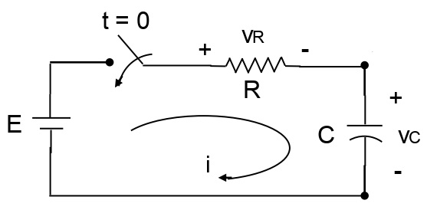 | L3 | CO2 | [5M]
13. | a) | Explain the properties of driving point function? | L6 | CO3 | [5M]
 | b) | For the given network function, draw pole-zero plot. V(s) = 5(s+5)/(s+2)(s+7) | L1 | CO3 | [5M]
14. | a) | Obtain the z parameters for the network in Fig.  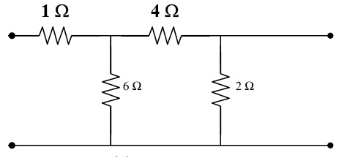 | L3 | CO4 | [5M]
 | b) | Discuss the condition of Reciprocity in h-Parameter representation. | L2 | CO4 | [5M]
15. | a) | What is a constant K low pass filter, derive its characteristics impedance | L5 | CO5 | [5M]
 | b) | A T section low pass filter has an inductance of 30 mH in each of the series arms and shunt arm capacitance of 0.25micro farad. Calculate the cut off frequency, characteristic impedance and phase shift at 1 KHz. | L3 | CO5 | [5M]
16. | a) | Write note on i) Half wave symmetry ii) Quarter wave symmetry | L1 | CO6 | [5M]
 | b) | What are the fourier coefficients? Derive the expressions for the fourier coefficients of the fourier series. | L5 | CO6 | [5M]
17. | a) | State the power relations for a three phase system and explain a power triangle. | L1 | CO1 | [4M]
 | b) | Explain initial conditions of various elements. | L6 | CO2 | [3M]
 | c) | Explain the significance of pole and zeros. | L2 | CO3 | [3M]
18. | a) | Express ABCD parameters in terms of h parameters. | L5 | CO4 | [4M]
 | b) | A prototype high pass filter has a cut off frequency of 8 KHz and nominal impedance of 600 ohms. Calculate the values of inductance and capacitance used in the filter. | L3 | CO5 | [3M]
 | c) | Find the fourier transform of the time function 3e^{-t} cos4t u(t) | L3 | CO6 | [3M]

-- 00 -- 00 –

